**Report on “HAPPEN”**

**Submitted to:**

Asif Khan Shakir

Lecturer, Department of Software Engineering

Daffodil International University

**Submitted by:**

**Name:** Azmia Hoque Radhio

**ID:** 171-35-1932

**Section:** B

**Course Code:** SWE 313

**Course title:** .Net Programming with Lab

Department of Software Engineering

Daffodil International University

**Table of content: Page**

**Case Study ---------------------------------------------------------------------------------- 3**

**Functional Requirements ---------------------------------------------------------------------------- 3**

**Non-functional Requirements----------------------------------------------------------------------- 3**

**Use-case Diagram----------------------------------------------------------------------------------- 4**

**Activity Diagram----------------------------------------------------------------------------------------5**

**Sequence Diagram for Manager---------------------------------------------------------------------6**

**Sequence Diagram for Member----------------------------------------------------------------------6**

**Class Diagram------------------------------------------------------------------------------------ 7**

**Entity relationship diagram--------------------------------------------------------------------------8**

**1. Case Study**

**In our real-life scenario,** we work in many projects or somehow involved in many projects, but in an undisciplined way. We do not maintain our workflow or keep tracks so we cannot see the project overview Or current state we’re in, team collaboration also done in a messy way. So, the project named **‘HAAPEN’** helps us to create projects and associate individuals and distribute tasks or collaborate and keep track, all in one place

**2. Functional Requirements**

* A project manager may use the software to map project tasks and visually describe task interactions.
* Allows the project manager to create and assign tasks, establish deadlines, and produce status reports.
* The software must have the ability to send email to project member for assigning every task/project and deadline
* The software must have the ability to Commenting with member and manager with each other.

**3. Non-functional Requirements**

* Members never allowed to update their Project information.
* This software should be capable enough to handle 100 users without affecting its performance
* Privacy of information, the export of restricted technologies, intellectual property rights, etc. should be audited.

**Use-case Diagram**

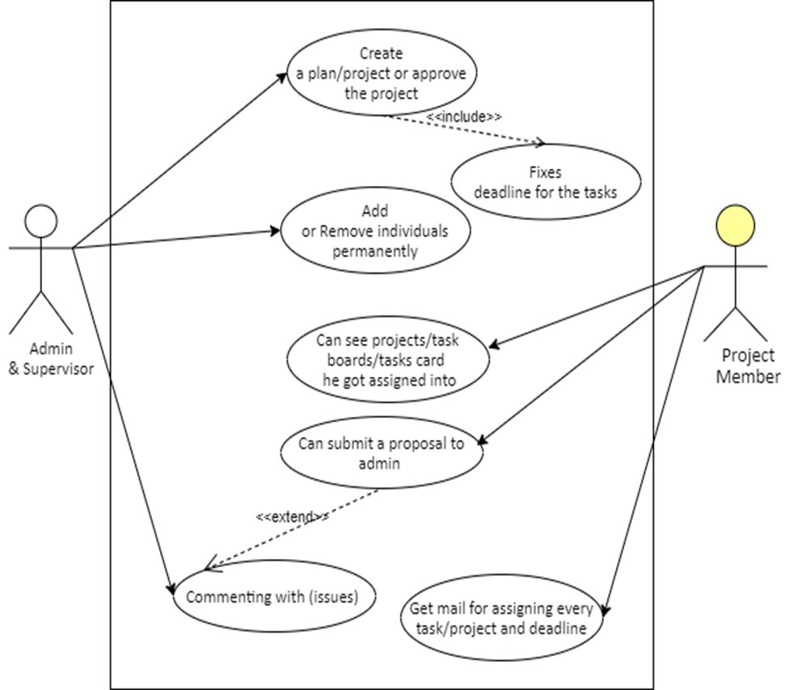

**Activity Diagram**

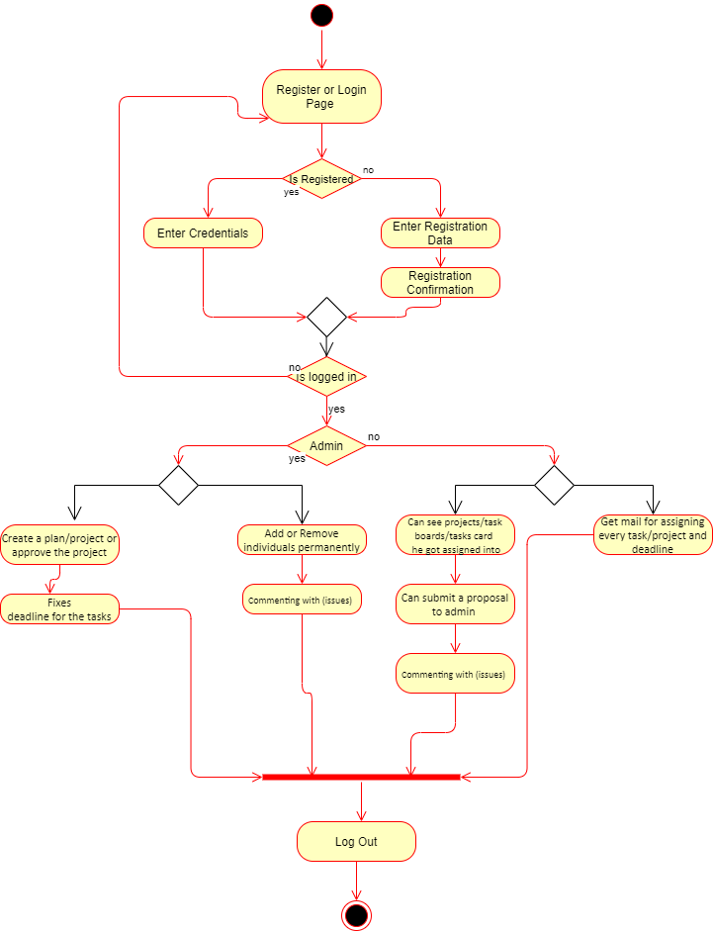

**Sequence Diagram for Manager**

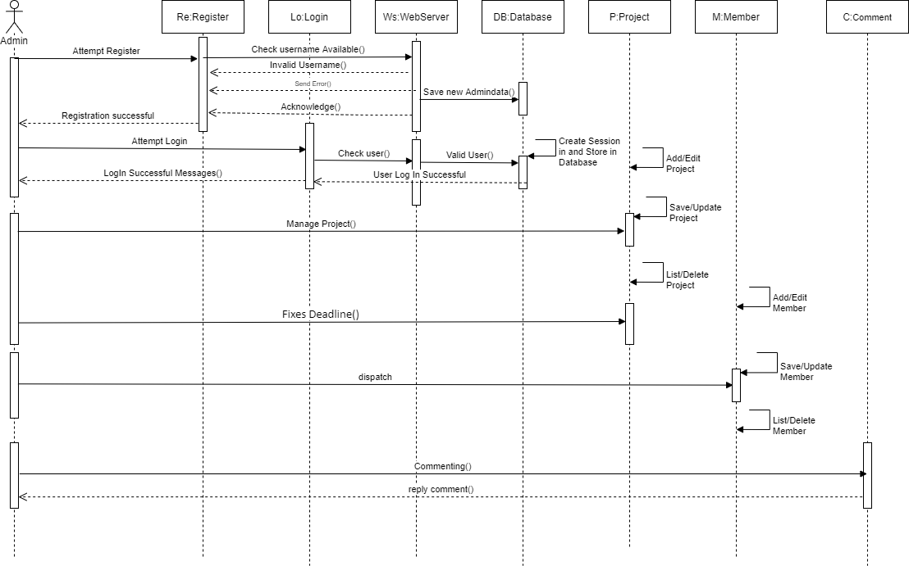

**Sequence Diagram for Member**

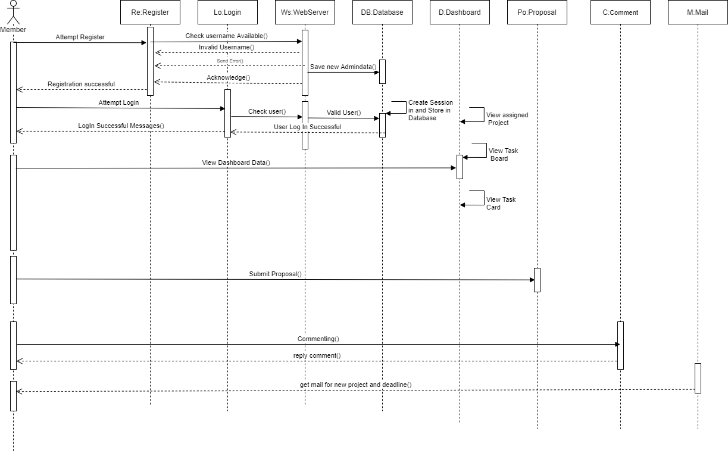

**Class Diagram**

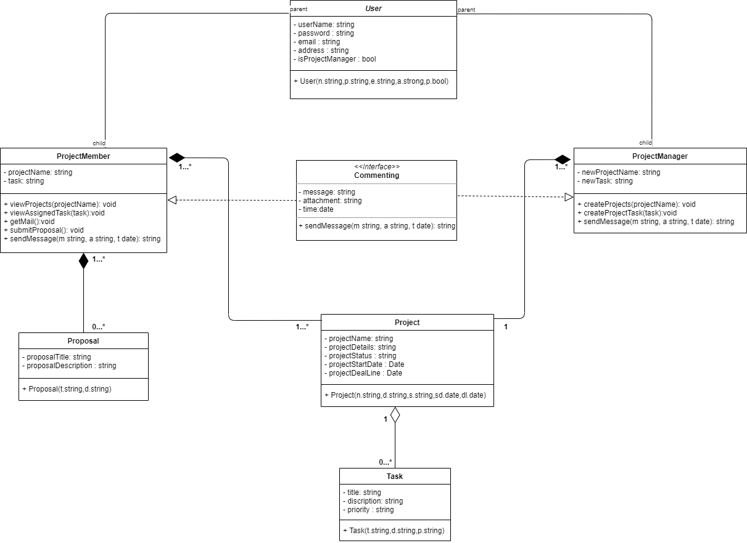

**Entity relationship diagram**

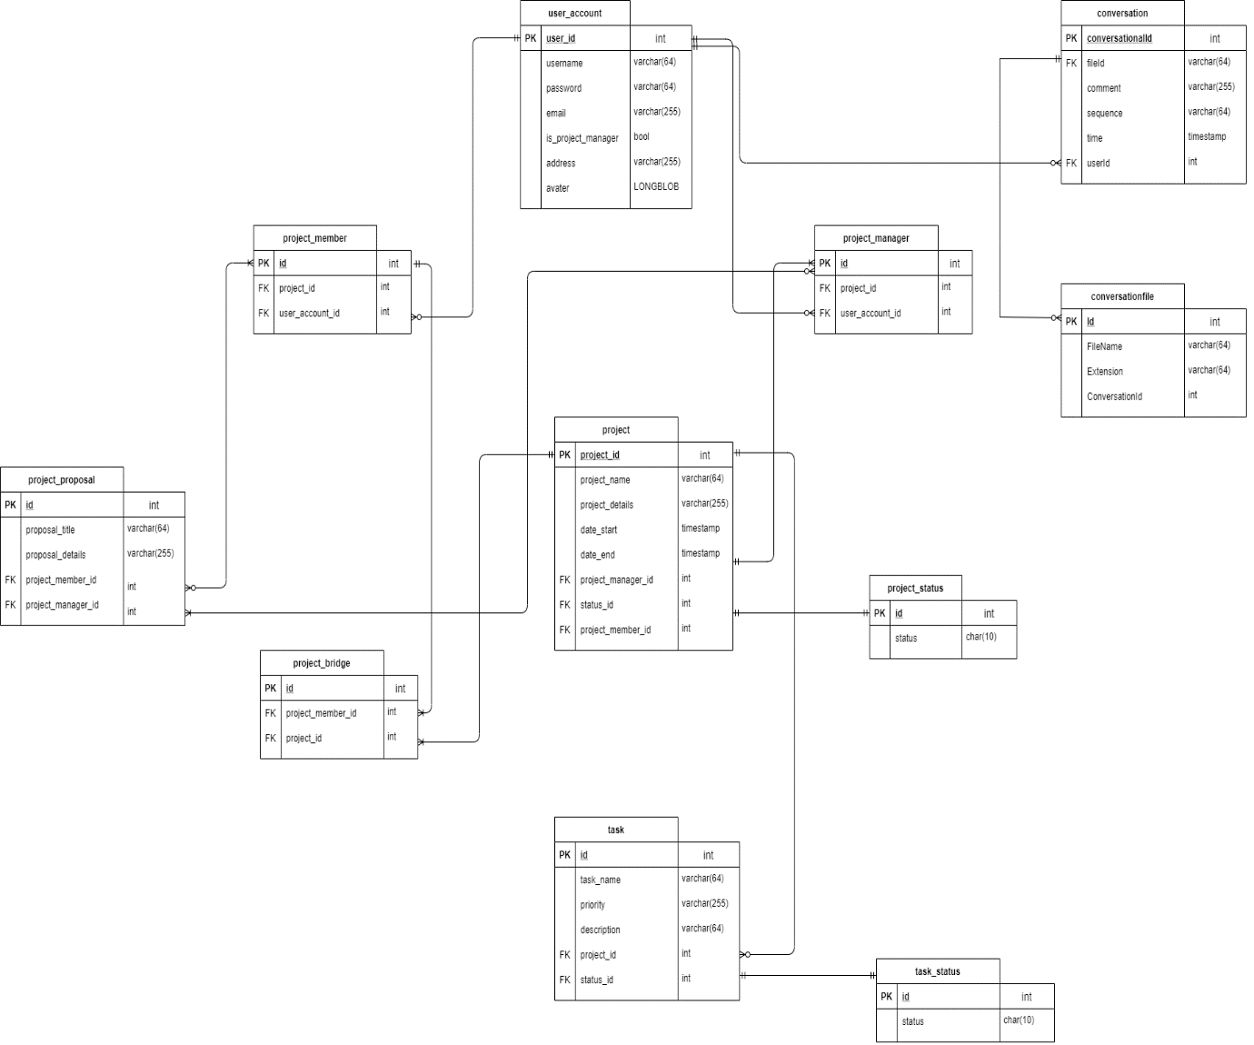

**THANK YOU ☺**